EXPERIMENT

Q1)

1. Find the names and loan numbers of all customers who have a loan at the Perryridge branch

SELECT customer_name, loan_number

FROM customer

JOIN loan ON customer.customer_id = loan.customer_id

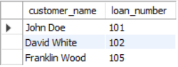WHERE branch_name = 'Perryridge';

2.Display the list in alphabetic order all customers who have a loan at the Perryridge branch

SELECT DISTINCT customer_name

FROM customer

JOIN loan ON customer.customer_id = loan.customer_id

WHERE branch_name = 'Perryridge'

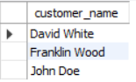ORDER BY customer_name ASC;

3.Find names of all branches with customer who have account in the bank and live in city whose name start with S.

SELECT DISTINCT branch_name

FROM customer

JOIN account ON customer.customer_id = account.customer_id

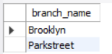WHERE customer.city LIKE 'S%';

4.For all customers who have a loan from the bank, find their names, loan numbers, and loan amount

SELECT customer_name, loan_number, loan_amount

FROM customer

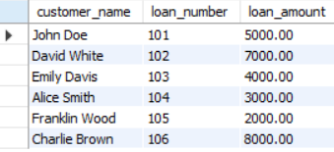JOIN loan ON customer.customer_id = loan.customer_id;

5.Find the list of all customers in alphabetic order who have a loan at the Parkstreet branch

SELECT DISTINCT customer_name

FROM customer

JOIN loan ON customer.customer_id = loan.customer_id

WHERE branch_name = 'Parkstreet'

ORDER BY customer_name ASC;

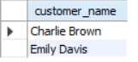

6. For all customers who have a loan from the bank, find their names, loan numbers, and loan amount

SELECT customer_name, loan_number,loan_amount

FROM customer

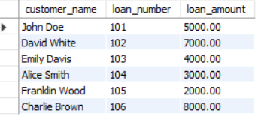JOIN loan ON customer.customer_id = loan.customer_id;

7.Find the customer names, loan numbers, and loan amounts, for all loans at the Perryridge branch.

SELECT customer_name,loan_number,loan_amount

FROM customer

JOIN loan ON customer.customer_id=loan.customer_id

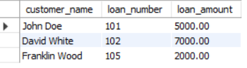WHERE branch_name='Perryridge';

8.For all customers who have a loan from the bank, find their names and loan numbers with the attribute loan_number replaced by loan_id.

SELECT customer_name,loan_number as loan_id

FROM customer

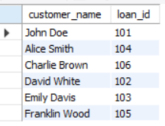JOIN loan ON customer.customer_id=loan.customer_id;

9.Find the name, account number, and balance of all customers who have an account

SELECT customer_name, account_number, balance

FROM customer

JOIN account ON customer.customer_id = account.customer_id;

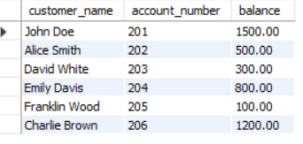

10.Find the name, loan number, and amunt of all customers who have an loan from Perryridge branch

SELECT customer_name,loan_number,loan_amount

FROM customer

JOIN loan ON customer.customer_id=loan.customer_id

WHERE branch_name='Perryridge';

11.Find the name, account number, and balance of all customers who have an account with a balance of $400 or less.

SELECT customer_name,account_number,balance

FROM customer

JOIN account ON customer.customer_id=account.customer_id

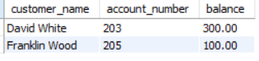WHERE balance <= 400;

12.List all accounts of Brooklyn branch

SELECT *

FROM account

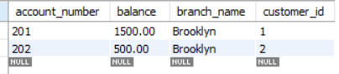WHERE branch_name = 'Brooklyn';

Q2)

1.Find all information of sailors who have reserved boat number 101.

SELECT S.*

FROM Sailors S

JOIN Reserves R ON S.sid = R.sid

WHERE R.bid = 101;

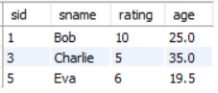

2. Find the name of boat reserved by Bob.

SELECT B.bname

FROM Boats B

JOIN Reserves R ON B.bid = R.bid

JOIN Sailors S ON R.sid = S.sid

WHERE S.sname = 'Bob';



4. Find the names of sailors who have reserved at least one boat.

SELECT DISTINCT S.sname

FROM Sailors S

JOIN Reserves R ON S.sid = R.sid;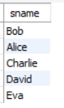

5. Find the ids and names of sailors who have reserved two different boats on the same day.

SELECT S.sid, S.sname

FROM Sailors S

JOIN Reserves R1 ON S.sid = R1.sid

JOIN Reserves R2 ON S.sid = R2.sid AND R1.day = R2.day AND R1.bid <> R2.bid;



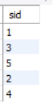6. Find the ids of sailors who have reserved a red boat or a green boat

SELECT DISTINCT R.sid

FROM Reserves R

JOIN Boats B ON R.bid = B.bid

WHERE B.color IN ('Red', 'Green');

7. Find the name and the age of the youngest sailor

SELECT sname, age

FROM Sailors

WHERE age = (SELECT MIN(age) FROM Sailors);

8. Count the number of different sailor names

SELECT COUNT(DISTINCT sname) AS Num_Sailors

FROM Sailors;

9. Find the average age of sailors for each rating level

SELECT rating, AVG(age) AS Avg_Age

FROM Sailors

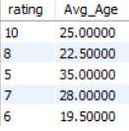GROUP

10. Find the average age of sailors for each rating level that has at least two sailors.

BY rating;

SELECT rating, AVG(age) AS Avg_Age

FROM Sailors

GROUP BY rating

HAVING COUNT(sid) >= 2;